Executive Summary: Seismic Event Classification from Waveforms
Justin Pickett, Eivind Joerstad, Shanece Esdaille
Project Github
https://github.com/Erdos-Projects/fall-2025-brain-tumor-diagnosis/ Problem
Problem Statement
Can a simple classification model reliably distinguish earthquakes from explosions? Can it do this from waveforms only, or do we need coordinated data from several stations (e.g. depth) or other non-seismic data (e.g. time of day) to get a reliable estimate?

Motivation
Earthquakes and underground nuclear explosions can produce similar seismic signals which may make them indistinguishable or difficult to distinguish. Correctly identifying the source of seismic events is important for monitoring nuclear testing. Both events can produce seismic waves, so simply detecting shaking isn't enough. The challenge is to find patterns that help distinguish the two sources.

Stakeholders and KPIs
Seismologists/researchers, agencies that build hazard models from earthquake catalogs (e.g. US Geological Survey). More broadly, nuclear-test monitoring (e.g. CTBTO). Our primary metric is average precision, and our secondary metrics are ROC-AUC, recall, precision and F1-score with 0.5 threshold.

Data source
Pacific Northwest Curated Seismic Dataset (2002-2022)¹

Modeling approach/methodology
We analyzed 38,581 events: 32,913 earthquakes (85.31%) and 5,668 explosions (14.69%). We combined recordings into one row per event and compared logistic regression, a shallow decision tree, and a random forest, each using catalog information alone versus catalog information plus waveform features. We compared catalog only features including location, magnitude, time, and catalog features + waveform features (e.g., spectral entropy, crest features). We tested depth separately and compared it with our baseline features. We evaluated three classification models; logistic regression, decision tree and random forest model. Using a geographic holdout, we trained on folds 1, 2, 4 and 5 and tested on fold 3.

Result
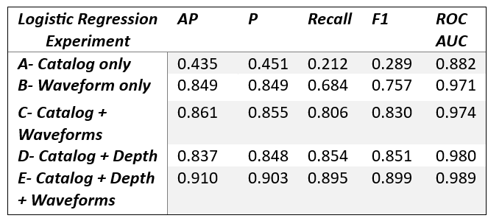
Our results indicate that seismic waveform measurements do substantially improve the identification of explosions compared with catalog information alone. This improvement was observed both with and without depth features (Experiments E and C) and across all three classification models used in this study. Combining catalog, depth, and waveform features (Experiment E) produced the best overall results for Logistic Regression and Random Forest. Random Forest achieved the highest Average Precision (0.960), while Logistic Regression achieved the highest F1 Score (0.899). The tables below illustrate the values of the evaluated KPIs for all three models.
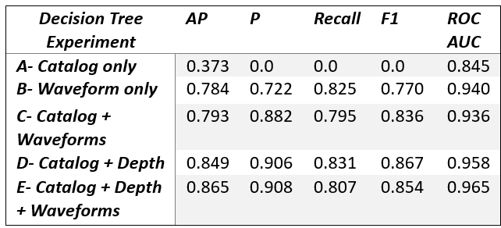
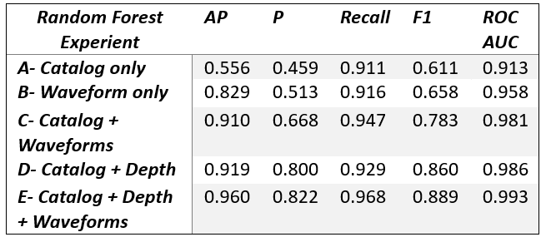

Interpretation
- Waveform features matter: Experiment B performs substantially better than catalog-only Experiment A for all 3 models, particularly for Logistic Regression and Random Forest.
- Combining features generally helps: Adding catalog, depth, and waveform information improves performance for Logistic Regression and Random Forest.
- Random Forest benefits most from the full feature combination: Its Average Precision reaches 0.960.
- Logistic Regression remains competitive: It achieves the highest F1 Score (0.8988) and precision (0.9028) for Experiment E.
- Decision Tree behaves differently: Although it achieves the highest precision (0.906) for Experiment E, its best F1 Score is Experiment D (0.861), rather than Experiment E.
- Overall, waveform features improved model performance, while the choice of model depends on the evaluation metric and practical requirements (e.g., Average Precision and ROC AUC measure discrimination across thresholds, whereas precision, recall, and F1 depend on the classification threshold)

Future work
Future work could test the model across more geographical regions, expand the dataset to include additional seismic events, and explore other seismic features that may improve discrimination. Another goal is to investigate how automated classification could support real-world seismic monitoring by helping analysts identify events that require further investigation.

